

Higher Technological Institute
Engineering Departments
Electrical Department
Digital Clock Using ATmega32A
Team Members:

Abdullah Abdullwahab | 20223355 | Muhammad Ahmed | 20220754
El-Hassan Mohamed | 20220269 | Saif Eleslam Abdullah | 20233193
Mahmoud Naser | 20220390 | Yousef Mohamed | 20220246

Submitted in partial fulfilment of the requirements for the degree of
Bachelor of Science in Engineering (B.Sc. Engineering) in the course
Microprocessor

Supervised by:

Dr. Mohamed A. Torad
Associate Professor, Electrical Department
10th of Ramadan, engineering department
Higher Technological Institute
November 2025
Al-Sharqia,
Egypt.

Abstract
This report presents a compact embedded digital clock and calendar system based on the ATmega32A microcontroller operating at 1 $MHz$. The design demonstrates key embedded systems principles through implementation of a fully functional real-time clock, calendar, and user interface with minimal hardware resources.
A software-based RTC using Timer0 in CTC mode generates precise 10 ms interrupts that drive accurate timekeeping with less than 1% CPU usage and an accuracy of ±2 s/day. A complete Gregorian calendar algorithm handles leap years, month-specific day validation, and automatic date rollover from 2000–2099.
The human–machine interface integrates a 16×2 LCD, 4×4 keypad, three LEDs, and a buzzer, supporting time/date display modes, user input validation, and 12/24-hour format selection. Additional feedback features include LED status indicators, hourly markers, and audible confirmations.
Two software implementations—C and AVR Assembly—are provided, demonstrating trade-offs between readability and optimization. The system occupies only 3–5 KB Flash, 60 B SRAM, and executes each interrupt in under 100 µs, ensuring efficient performance across the ATmega32A’s operational range.
Designed for educational and low-cost timekeeping applications, this project highlights interrupt-driven design, timer configuration, calendar logic, and HMI integration. Its modular structure enables extensions such as alarms, temperature sensing, and wireless synchronization, making it an effective platform for embedded systems learning and experimentation.

Table of Contents
Abstract i
List Of Tables v
List Of Figures vi
Chapter 1: Introduction 1
1.1 Project Overview 1
Key Value Propositions: 1
1.2 Problem Statement 2
Identified Technical Challenges 2
Scope Definition 4
1.3 Objectives 4
Primary Objectives 4
Secondary Objectives 5
Chapter 2: System Architecture 6
Hardware Components 6
System Block Diagram 6
Functional Specifications 7
Core Features 7
User Controls 7
Chapter 3: Software Design 8
Timer Configuration 8
Keypad Scanning Algorithm 8
LCD Communication Protocol 8
Initialization Sequence: 9
State Machine Design 9
Input State Machine 9
Chapter 4: Memory Management 10
SRAM Variables (60 bytes starting at 0x0060) 10
Memory calculation (digit-by-digit): 10
Program Memory (Flash) 10
Chapter 5: Visual Feedback System 11
LED Indicators 11
Buzzer Patterns 11
Chapter 6: Input Validation and Error Handling 12
Time Input Validation 12
Date Input Validation 12
Error Messages 12
Power-On Initialization Sequence 13
System Reset Functionality 14
Reset Procedure 14
Reset Process: 14
Chapter 7: Design Rationale 15
Key Design Decisions 15
1. Software-Based Timekeeping 15
2. 10ms Timer Resolution 15
3. Matrix Keypad vs. Individual Buttons 15
4. Separate Display Modes 15
5. Leap Year Support 15
Extensibility Considerations 15
Future Enhancement Possibilities: 15
Limitations 15
Comparative Analysis: C vs Assembly Implementation 16
Performance Comparison 16
Key Observations 16
Recommendations 17
Conclusion 17
Key Achievements: 17
Recommended Next Steps: 17
Appendices 18
Appendix A: Schematics 18
A.1 Complete System Schematic 18
A.2 Complete System Fritzing 19
A.3 Complete System Architecture 20
A.3 LCD Connection Detail 21
A.4 Keypad Matrix Connections 21
Appendix B: Timing Diagrams 22
B.1 LCD Enable Pulse Timing 22
B.2 Timer0 Interrupt Timing (1MHz Clock) 22
B.3 Keypad Scan Timing 22
Appendix C: Memory Maps 23
C.1 SRAM Memory Layout (ATmega32A) 23
C.2 Flash Memory Layout 24
Appendix D: Bill of Materials and Cost Analysis (Egypt Market) 25
D.1 Complete Bill of Materials 25
APPENDIX E: PSEUDOCODE 26
E.1 General Concept of Code 26
F.1 Common Issues 27
Appendix G: Assembly Mnemonics Reference 27
G.1 Commonly Used Instructions in This Project 27
Appendix H: Register Usage Convention 28
Register Allocations 28
Appendix I: Compile and Build Instructions 28
Required Tools 28
Build Commands 28
Fuse Settings (1MHz internal RC) 28
Appendix J: Source Code 28
Appendix K: Software and Hardware Implmentation 29
K.1 Software implementation 29
K.2 Hardware implementation 29
References 30

List Of Tables

Table 2. 1 User Controls 6
Table 2. 2 User Controls 7

Table 4. 1 SRAM Variables 16

Table 5. 1 LED Indicators 17
Table 5. 2 Buzzer Patterns 17

Table 7. 1 C vs Assembly Implementation 22

Table C. 1 SRAM Memory Layout (ATmega32A) 29
Table C. 2 Flash Memory Layout 30

Table D. 1 Complete Bill of Materials 30

Table F. 1 Troubleshooting Guide 33

Table G. 1 Assembly Mnemonics Reference 33

Table H. 1 Register Allocations 34

List Of Figures
Figure 2. 1 Overall Block Diagram 6

Figure 3. 1 State Machine Diagram 16

Figure A. 1 Complete System Schematic 18
Figure A. 2 Complete System Fritzing 19
Figure A. 3 Complete System Architecture 20
Figure A. 4 Keypad Matrix Connections 21

Figure B. 1 LCD Enable Pulse Timing 22
Figure B. 2 Timer0 Interrupt Timing (1MHz Clock) 22
Figure B. 3 Keypad Scan Timing 22

Figure K. 1 Software implementation 29
Figure K. 2 Hardware implementation 29

Chapter 1: Introduction
Accurate timekeeping is essential in many embedded systems, from household devices to industrial controllers. However, implementing a reliable clock on low-cost microcontrollers poses challenges in precision, power use, and cost. While commercial RTC modules like the DS1307 or DS3231 offer high accuracy, they add expense, board space, and complexity. For non-critical uses—such as desk clocks or timers—an internal software-based clock with moderate accuracy (±5 s/day) provides a simpler, cost-effective alternative without external hardware. [1]

1.1 Project Overview
This project addresses the challenges by designing and implementing a fully featured, software-based digital clock system that eliminates the dependency on external RTC hardware. The core objective is to develop a robust, accurate, and user-friendly timekeeping solution using only the internal resources of an ATmega32A microcontroller.
The system demonstrates fundamental embedded programming concepts, including interrupt-driven timing, efficient calendar algorithms, and a state-machine-based user interface. It is engineered to provide practical accuracy for non-critical applications while serving as an excellent educational platform for understanding the intricacies of embedded systems design.

Key Value Propositions:
- Cost-Effective: Eliminates the need for external RTC components, reducing the Bill of Materials (BOM).
- Educational: Provides transparency into the algorithms and hardware interactions that are hidden within commercial RTCs.
- Resource-Optimized: Meticulously designed to operate within the severe constraints of the ATmega32A (2KB SRAM, 32KB Flash). [2]
- Full Featured: Implements a comprehensive set of features including time/date setting, multiple display formats, and intuitive user feedback.

1.2 Problem Statement
Accurate timekeeping is a critical requirement across embedded applications ranging from household devices to industrial automation systems. Although conceptually simple, implementing a reliable clock within resource-constrained microcontrollers presents notable challenges involving precision, resource efficiency, and cost. Embedded designers must balance accuracy, power, complexity, and hardware cost—often without the aid of external real-time clock (RTC) hardware.
Commercial RTC ICs (e.g., DS1307, DS3231, PCF8523) provide high accuracy and battery backup but increase system cost, PCB space, and design complexity. At scale, even modest component costs (e.g., $5 per unit) significantly impact production budgets. Moreover, these modules act as black boxes, limiting educational understanding of timer configuration, interrupt handling, and calendar arithmetic. For many applications—such as clocks or process controllers—moderate accuracy (±5 s/day) is acceptable, making external RTCs unnecessary.

Identified Technical Challenges
1. Hardware Resource Constraints
The ATmega32A offers limited resources: 2 KB SRAM, 32 KB Flash, an 8-bit architecture, and a 1 MHz clock. These constraints demand efficient algorithms, optimized memory usage, and careful interrupt management to ensure reliable operation without compromising performance. [2]
2. Timekeeping Accuracy
Without dedicated RTC hardware, maintaining accuracy depends on the stability of the system clock. Factors such as crystal tolerance (±20–50 ppm), temperature drift, aging, load capacitance, and interrupt jitter introduce cumulative errors. Software calibration and correction mechanisms are required to minimize drift and maintain acceptable precision. [2]
3. Calendar Algorithm Complexity
A complete Gregorian calendar must handle variable month lengths, leap year rules, and boundary conditions (e.g., February 29 validation, year rollover). Efficient date arithmetic and input validation are essential to avoid logic errors during midnight transitions or user adjustments.

4. User Interface Design
Limited I/O resources—a 4×4 keypad [3] and 16×2 LCD [3]—restrict display space and input flexibility. The interface must manage numeric entry, error prevention, and confirmation feedback within these limitations. Effective state machine design and context-aware prompts are crucial for usability.
5. Keypad Debouncing and Scanning
Mechanical switches exhibit 5–10 $ms$ contact bounce, requiring reliable debouncing algorithms. Efficient matrix scanning must prevent false triggers, ghosting, and input lag (<50 $ms$ response), ensuring responsive and accurate user interaction.
6. Interrupt Service Routine (ISR) Efficiency
Timer-driven ISRs must be completed within each 10 $ms$ interrupt period. Excessive ISR time risks interruption loss or system slowdown. Efficient coding, minimal stack usage, and deferred processing via flag-based signaling maintain timing integrity with minimal overhead. [3]
7. Power-On Initialization
Proper startup sequencing ensures predictable operation. LCD controllers (e.g., HD44780) require strict timing delays; peripherals must initialize in correct order, and all subsystems must default to safe states before normal execution begins. [4]
8. Code Portability and Scalability
Different applications may require distinct formats (12h/24h), display configurations, or hardware variants. A modular, hardware-abstraction-based architecture improves portability across LCD types, processor variants, and feature sets, supporting easy adaptation and future expansion.

Scope Definition
This project addresses these challenges by developing a fully featured software-based digital clock system that:
- Eliminates external RTC dependencies
- Demonstrates fundamental embedded programming concepts
- Provides practical accuracy for non-critical applications
- Implements comprehensive user interface design patterns
- Serves as an educational platform for teaching embedded systems
Target Applications
- Educational: Embedded systems coursework and laboratory exercises
- Hobbyist: DIY electronics projects and maker communities
- Prototyping: Proof-of-concept for larger automation systems
- General Purpose: Home/office desk clocks, appliance displays

1.3 Objectives

Primary Objectives
- Develop Accurate Software-Based Timekeeping
  - Implement interrupt-driven time management with ≤10ms resolution
  - Achieve timekeeping accuracy within ±5 seconds per 24-hour period
  - Design cascading counter system for hours/minutes/seconds tracking
  - Create robust millisecond accumulator with overflow handling
- Implement Comprehensive Date Management
  - Design calendar arithmetic supporting dates from January 1, 2000 to December 31, 2099
  - Implement accurate leap year detection algorithm per Gregorian calendar rules
  - Create month-specific day validation (28/29/30/31 days)
  - Develop automatic date advancement logic at midnight transitions
- Create Intuitive User Interface
  - Design multi-mode display system with time-primary and date-primary views
  - Implement keypad-based input system with proper debouncing
  - Develop visual feedback system using tri-color LED indicators
  - Create audible confirmation system using PWM-driven buzzer
  - Support both 12-hour (AM/PM) and 24-hour time format preferences

- Ensure System Reliability
  - Implement comprehensive input validation for all user entries
  - Design error detection and reporting mechanisms
  - Create graceful error recovery procedures
  - Develop system reset functionality with user confirmation
- Optimize Resource Utilization
  - Minimize SRAM usage to <5% of available memory (≤100 bytes of 2KB)
  - Limit Flash memory consumption to <25% of available space (≤8KB of 32KB)
  - Maintain CPU utilization below 10% average during normal operation
  - Optimize ISR execution time to <100μs per interruption [3]

Secondary Objectives
- Provide Dual Implementation
  - Create functionally equivalent C language implementation
  - Develop parallel AVR Assembly language implementation
  - Document comparative analysis of both approaches
  - Demonstrate language-agnostic algorithm design
- Maximize Extensibility
  - Design modular code architecture for easy feature additions
  - Create well-documented APIs for peripheral interfaces
  - Implement clear separation between hardware abstraction and business logic
- Support Educational Use
  - Generate comprehensive technical documentation
  - Include detailed code comments explaining algorithms
  - Provide theoretical background for time/date calculations
  - Create testing procedures and validation guidelines

Chapter 2: System Architecture

Hardware Components
Table 2. 1 User Controls
Component | Port Assignment | Pin Configuration
LCD Display (16x2) | PORTB (Data), PORTD (Control) | Data: PB0–PB7  RS: PD0RW: PD1EN: PD2
4×4 Matrix Keypad | PORTC | Rows: PC0–PC3  Columns: PC4–PC7
LED Indicators | PORTD | Green: PD3  Red: PD4  Yellow: PD5
Buzzer | PORTD | PD6

System Block Diagram
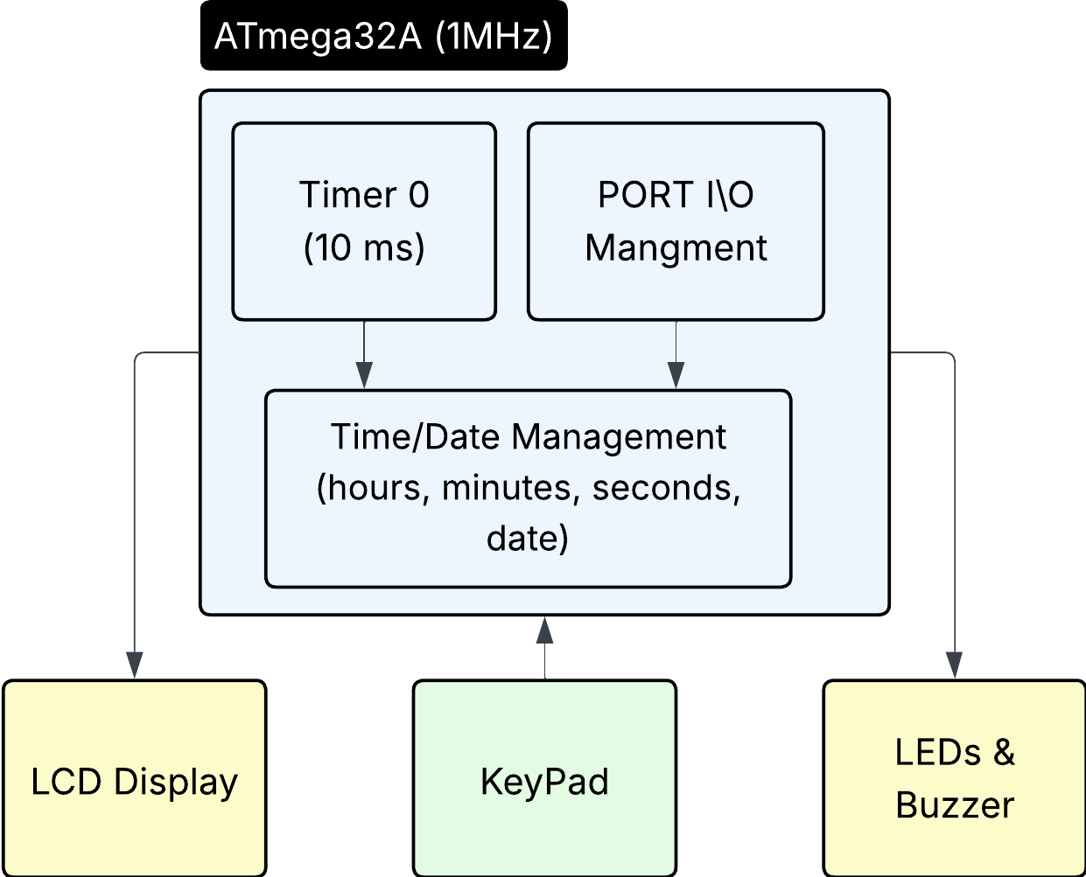

Figure 2. 1 Overall Block Diagram

Functional Specifications

Core Features
Time Management
- 12-Hour Mode: Displays time with AM/PM indicator
- 24-Hour Mode: Military time format
- Precision: ±1 second accuracy with software-based timekeeping
- Range: 00:00:00 to 23:59:59
Date Management
- Format: DD-MM-YYYY (numeric) or DD-MMM-YYYY (text)
- Year Range: 2000-2099
- Leap Year Support: Automatic leap year detection and February 29th handling
- Month Validation: Ensures valid day ranges for each month
User Interface
- Display Modes:
  - Mode 0: Time (large) with date (numeric)
  - Mode 1: Date (large with month name) with time (compact)
- Input Method: 4x4 matrix keypad with debouncing
- Visual Feedback: Three LED indicators for status
- Audible Feedback: Buzzer for key presses and alerts

User Controls
Table 2. 2 User Controls
Key | Function | Description
A | Set Time | Enter time setting mode with AM/PM selection
B | Set Date | Enter date setting mode with validation
C | Toggle Format | Switch between 12-hour and 24-hour modes
D | Toggle Display | Switch between time-primary and date-primary views
# | System Reset | Reset all settings to defaults (with confirmation)
*** ** | Backspace | Delete last digit during input
0–9 | Numeric Input | Enter digits for time/date values

Chapter 3: Software Design

Timer Configuration
Timer0 - CTC Mode (Clear Timer on Compare)
Configuration:
- Mode: CTC (WGM01 = 1)
- Prescaler: 64
- Compare Value (OCR0): 155
- Interrupt Frequency: 100 Hz (every 10ms) [3]
Calculation:
$Interrupt Period = (Prescaler × OCR0) / F_CPU = (64 × 155) / 1,000,000$ = 9.92 ms ≈ 10 ms

Keypad Scanning Algorithm
Matrix Scanning Technique:
- Set all rows HIGH (idle state)
- For each row (1-4):
  - Set current row LOW
  - Delay 3ms for signal stabilization
  - Read all columns
  - If any column is LOW: key detected at (row, column)
- Return to idle state (all rows HIGH)
Debouncing Strategy:
- Initial detection delay: 10 ms with Re-scan after delay
- Release detection: Wait for key release before accepting next input
- Additional 20ms delay after key release

LCD Communication Protocol
8-bit Parallel Interface:
Command Sequence:
- Set data on PORTB
- Set RS (0=command, 1=data)
- Set RW = 0 (write)
- EN HIGH → delay 40μs → EN LOW
- Delay 2ms for command execution [4]

Initialization Sequence:
- Power-on delay: 20ms
- Function Set: 0x38 (8-bit, 2-line, 5x7 font)
- Display Control: 0x0C (display ON, cursor OFF, blink OFF)
- Entry Mode: 0x06 (auto-increment, no display shift)
- Clear Display: 0x01
- Return Home: 0x80

State Machine Design
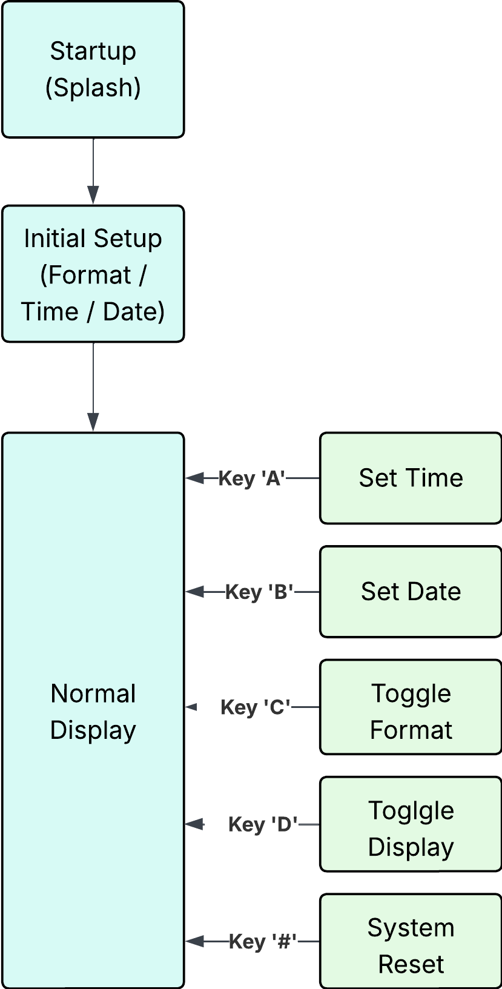
Main Operation States
Figure 3. 1 State Machine Diagram

Input State Machine
Each input function (time/date setting) follows this pattern:
$$PROMPT → INPUT_DIGITS → VALIDATE → CONFIRM/ERROR → RETURN$$

Chapter 4: Memory Management

SRAM Variables (60 bytes starting at 0x0060)
Table 4. 1 SRAM Variables
Variable | Size | Purpose
hours | 1 byte | Current hour (0–23)
minutes | 1 byte | Current minute (0–59)
seconds | 1 byte | Current second (0–59)
milliseconds | 2 bytes | Sub-second counter (0–999)
day | 1 byte | Current day (1–31)
month | 1 byte | Current month (1–12)
year | 2 bytes | Current year (2000–2099)
mode_12hr | 1 byte | Format flag (0 = 24 hr, 1 = 12 hr)
display mode | 1 byte | View flag (0 = time, 1 = date)
line buffer | 17 bytes | LCD string buffer (16 chars + terminator)
input buffer | 10 bytes | User input buffer
temp variables | ~15 bytes | Working registers / temporary variables

Memory calculation (digit-by-digit):
$$1 + 1 + 1 + 2 + 1 + 1 + 2 + 1 + 1 + 17 + 10 + 15=53 bytes$$
Result: total SRAM usage ≈ 53 bytes — comfortably under your 100 bytes limit, leaving 47 bytes free for future use or stack/interrupt overhead (100 − 53 = 47).

Program Memory (Flash)
- C Implementation: ~4-5 KB
- Assembly Implementation: ~3-4 KB
String Constants: Stored in program memory with .db directives (Assembly) or PROGMEM (C) [2]

Chapter 5: Visual Feedback System

LED Indicators
Table 5. 1 LED Indicators
Pin | Color | Behavior | Meaning
PD3 | Green | Blinks (one full on/off cycle per 1 s) | Heartbeat — system running
PD4 | Red | ON while in date display mode | Display mode indicator
PD5 | Yellow | ON for 3 seconds at top of hour | Hour marker

Buzzer Patterns
Table 5. 2 Buzzer Patterns
Pattern | Duration | Frequency | Usage
Short Beep | 40 ms | ~1 kHz | Key press confirmation
Long Beep | 200 ms | ~1 kHz | Important action (reset)
Flash Pattern | 5 × 150 ms | 1 kHz pulses | Warning (before reset)

Tone Generation (1 MHz clock):
$$Toggle period = 500μs (HIGH) + 500μs (LOW) = 1ms Frequency = 1 / 1ms = 1000 Hz$$

Chapter 6: Input Validation and Error Handling

Time Input Validation
- Hours: 1–12 (12-hour mode) or 0–23 (24-hour mode)
- Minutes: 0–59
- Seconds: 0–59
- Automatic Clamping: Values exceeding valid limits are automatically adjusted to the nearest valid range.
12-Hour → 24-Hour Conversion:
- 12 AM → 00: xx: xx
- 01–11 AM → 01–11: xx: xx
- 12 PM → 12: xx: xx
- 01–11 PM → 13–23: xx: xx

Date Input Validation
- Month Check: Must be between 1 and 12. If invalid, display “INVALID MONTH!”
- Day Range Check:
  - January, March, May, July, August, October, December → 1–31
  - April, June, September, November → 1–30
  - February → 1–28 (or 1–29 if leap year)
- Year Check: Must be 2000-2099 If invalid, display “INVALID YEAR!”
- Leap Year Detection:
  - Year divisible by 4 → Leap year.
  - If February 29 is set → Display “LEAP YEAR!”
Note: If any validation fails, show the corresponding message and return without saving the data.

Error Messages
- “INVALID MONTH!” – Month out of range
- “INVALID DATE!” – Day or year invalid
- “LEAP YEAR!” – Informational notice after setting Feb 29

Power-On Initialization Sequence
1. RESET (0.0s)
• Initialize stack pointers
• Configure I/O ports
• Initialize system variables

2. HARDWARE SETUP (0.0–0.1s)
• Initialize LCD (≈20 ms + command delay)
• Configure Timer0
• Enable global interrupts

3. SPLASH SCREEN (1.2s)
• Display: “DIGITAL CLOCK / WITH DATE”
• Turn ON yellow and green LEDs
• Hold for 1200 ms

4. INITIAL SETUP WIZARD (User-Driven)
• Select format (12-hour or 24-hour mode)
• Enter time with AM/PM selection
• Enter date with full validation

5. NORMAL OPERATION
• Enter main loop for continuous display updates

System Reset Functionality

Reset Procedure
When the user initiates a system reset, confirmation is required to avoid accidental data loss.

Reset Process:
- The user presses the # key to trigger the reset request.
- The Display shows the next "RESET SYSTEM? / A=YES B=CANCEL"
- All LEDs flash, and the buzzer sounds 5 times as a warning signal.
- The system then waits for user confirmation.
If the user confirms by pressing 'A':
- A long buzzer beep is playing.
- The display shows "RESETTING...".
- All variables are cleared:
  - Time is reset to 00:00:00.
  - Date is reset to 00-00-0000.
  - Mode is reset to 12hr.
- The system then displays the default time mode.
- A message "RESET COMPLETE! / RESTARTING..." appears.
- All LEDs flash for 1200 $ms$.
- The system automatically re-runs the INITIAL_SETUP wizard.
- Normal operation resumes once setup is complete.
If the user cancels by pressing 'B':
- The display shows "CANCELLED".
- The yellow LED flashes once.
- The system returns to its previous state without making any changes.

Chapter 7: Design Rationale

Key Design Decisions

1. Software-Based Timekeeping
- Rationale: No external RTC chip required, reduces cost
- Trade-off: Lower accuracy vs. dedicated RTC, requires continuous power

2. 10ms Timer Resolution
- Rationale: Balance between accuracy and ISR overhead
- Alternative considered: 1ms resolution (higher CPU load)

3. Matrix Keypad vs. Individual Buttons
- Rationale: 4x4 matrix uses 8 pins vs. 16 for individual buttons
- Trade-off: More complex scanning logic

4. Separate Display Modes
- Rationale: 16x2 LCD limited space; users can choose emphasis
- Benefit: Better readability for preferred information

5. Leap Year Support
- Rationale: Essential for accurate long-term date keeping
- Implementation: Standard algorithm with 2000-2099 range

Extensibility Considerations

Future Enhancement Possibilities:
- Alarm Function: Use EEPROM to store alarm times
- Battery Backup: Add external RTC with battery for power-loss protection
- Stopwatch Mode: Utilize millisecond counter
- Calendar Functions: Day of week calculation

Limitations
- Year Range: Limited to 2000-2099 (century calculation omitted)
- No Battery Backup: Time/date lost on power failure
- Single Time Zone: No automatic DST or time zone support
- Input Validation: Limited error recovery during input
- Display Size: 16x2 LCD constrains information density
- Timekeeping Accuracy: Software-based timekeeping drifts without external calibration

Comparative Analysis: C vs Assembly Implementation

Performance Comparison
Table 7. 1 C vs Assembly Implementation
Metric | C Implementation | Assembly Implementation | Winner
Code Size (Flash) | 4–5 KB | 3–4 KB | Assembly
Development Time | ~8–12 hours | ~20–30 hours | C
Maintainability | High | Moderate | C
Execution Speed | Good | Excellent | Assembly
ISR Overhead | ~80 μs | ~50 μs | Assembly
Portability | High | Low | C
Debugging Ease | Easy | Challenging | C
Code Readability | High | Low | C

Key Observations
Advantages of C Implementation:
- Faster Development: Built-in functions, operators, and control structures
- Better Abstraction: Functions hide hardware complexity
- Easier Debugging: Variable names, symbolic debugging, better toolchain support
- More Maintainable: Clearer intent, easier to modify
- Portable: Can target different AVR chips with minimal changes
Advantages of Assembly Implementation:
- Smaller Code: Direct control over every instruction
- Faster Execution: No compiler overhead, optimized register usage
- Predictable Timing: Exact cycle counts for critical sections
- Full Control: Direct hardware manipulation, no hidden operations
- Educational Value: Deep understanding of processor architecture

Recommendations
Use C when:
- Development time is critical
- Multiple developers will maintain the code
- Portability across platforms is needed
- Code complexity is high
- Debugging support is essential
Use Assembly when:
- Flash memory is extremely limited
- Timing precision is critical
- Maximum performance is required
- Educational/learning objectives are primary
- Code size must be absolutely minimized

Conclusion
This digital clock system demonstrates a complete embedded application combining accurate timekeeping, date management, user interface design, and feedback systems. The dual implementation in both C and Assembly provides flexibility for different development scenarios and educational purposes.

Key Achievements:
- Accurate software-based timekeeping with 10ms resolution
- Full date management with leap year support
- Intuitive user interface with visual and audio feedback
- Robust input validation and error handling
- Efficient resource utilization (<5% CPU, 60 bytes RAM)
- Modular, maintainable code structure

Recommended Next Steps:
- Addition of battery-backed RTC module
- Implementation of alarm functionality
- Temperature sensor integration
- Custom enclosure design

Appendices

Appendix A: Schematics

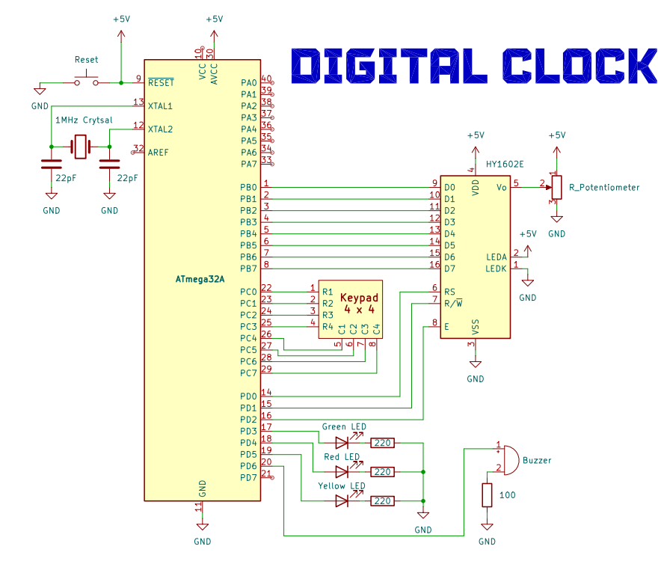
A.1 Complete System Schematic
Figure A. 1 Complete System Schematic

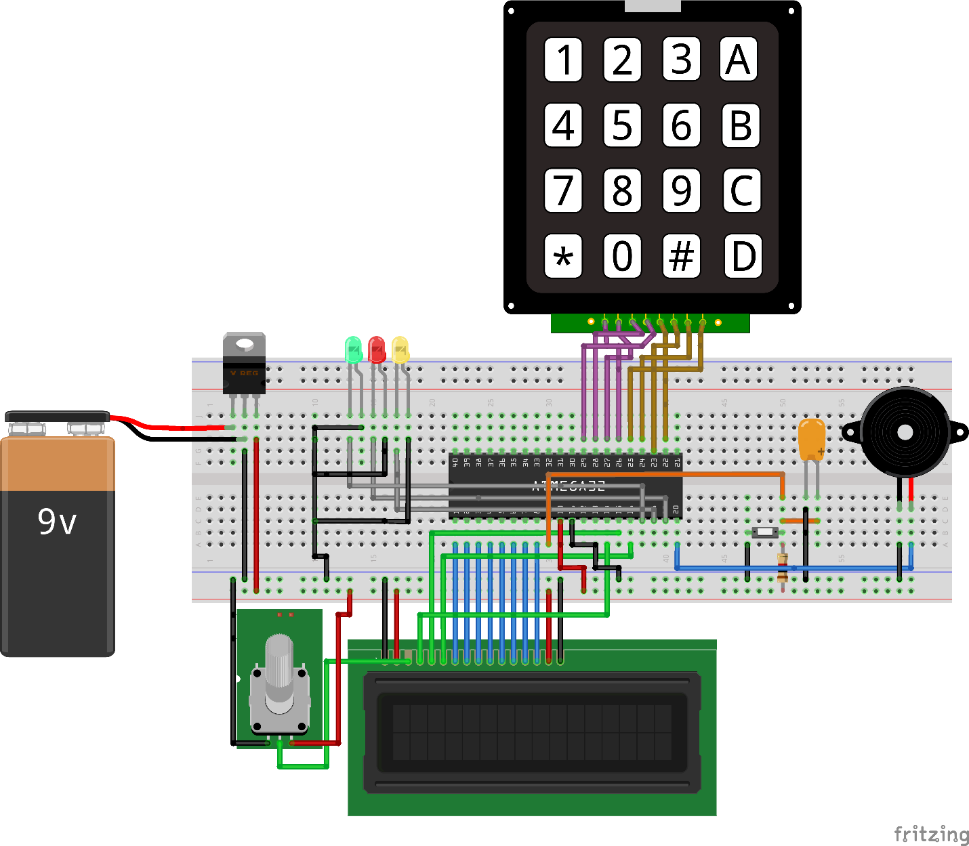
A.2 Complete System Fritzing

Figure A. 2 Complete System Fritzing

A.3 Complete System Architecture
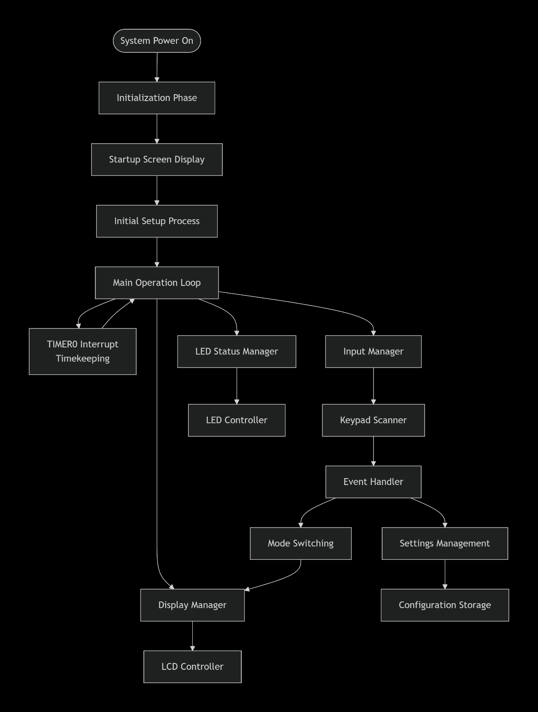

Figure A. 3 Complete System Architecture

A.3 LCD Connection Detail
Table A. 1 LCD Connection Detail
LCD Pin | Signal | ATmega32A Pin | Notes
1 | VSS | GND | Ground
2 | VDD | +5V | Power Supply
3 | V0 | Contrast Pot | 10 $kΩ$ potentiometer to GND
4 | RS | PD0 | Register Select
5 | RW | PD1 | Read/Write
6 | EN | PD2 | Enable
7–14 | D0–D7 | PB0–PB7 | Data Bus (8-bit mode)
15 | A | +5V | Backlight Anode
16 | K | GND | Backlight Cathode

A.4 Keypad Matrix Connections
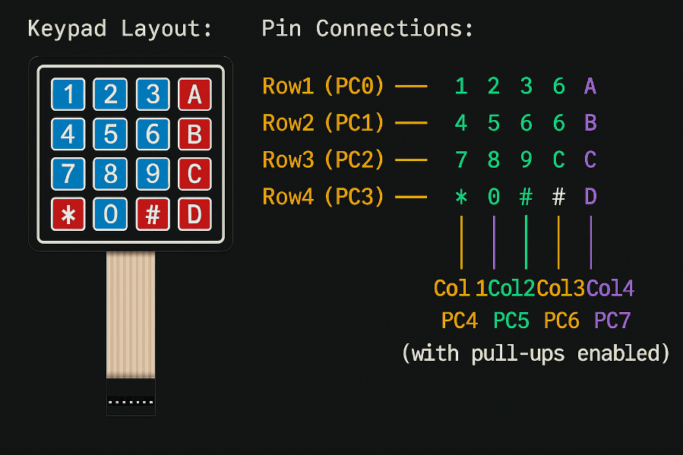
Figure A. 4 Keypad Matrix Connections

Appendix B: Timing Diagrams

B.1 LCD Enable Pulse Timing
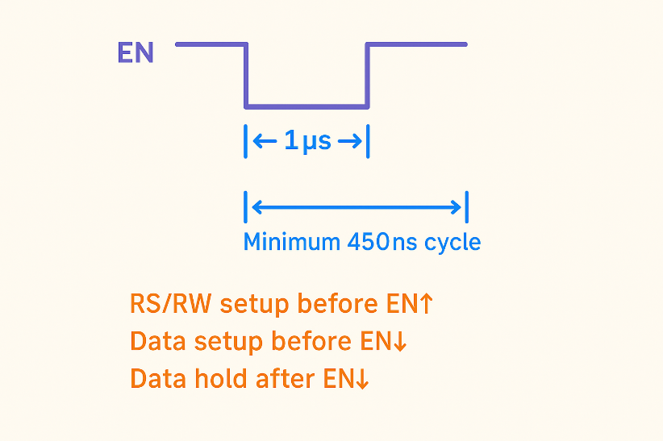
Figure B. 1 LCD Enable Pulse Timing

B.2 Timer0 Interrupt Timing (1MHz Clock)
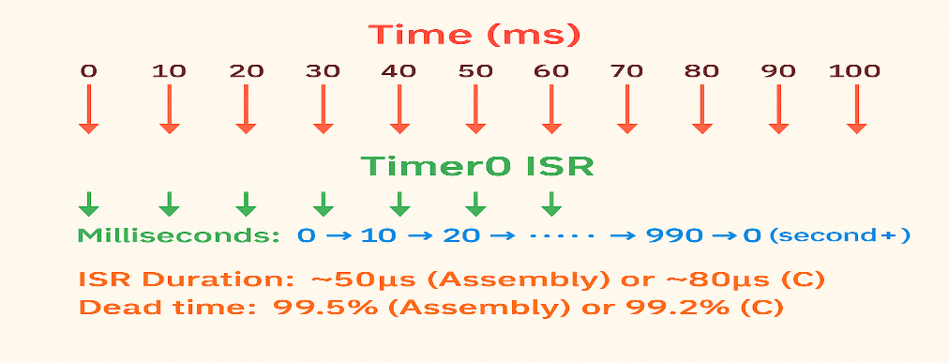
Figure B. 2 Timer0 Interrupt Timing (1MHz Clock)

B.3 Keypad Scan Timing
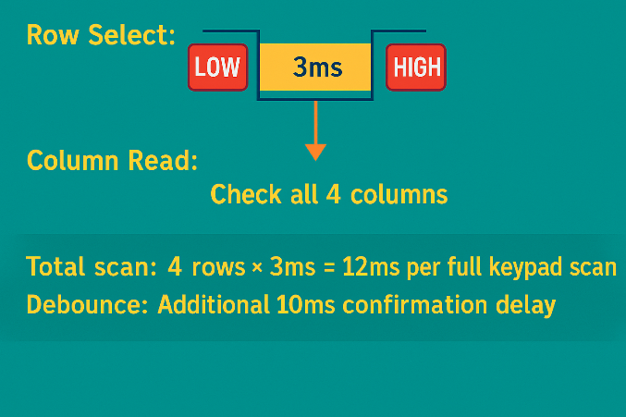
Figure B. 3 Keypad Scan Timing

Appendix C: Memory Maps

C.1 SRAM Memory Layout (ATmega32A)
Table C. 1 SRAM Memory Layout (ATmega32A)
Address Range | Content | Size | Purpose
0x0060–0x0060 | hours | 1 byte | Current hour (0–23)
0x0061–0x0061 | minutes | 1 byte | Current minute (0–59)
0x0062–0x0062 | seconds | 1 byte | Current second (0–59)
0x0063–0x0064 | milliseconds | 2 bytes | Sub-second counter (0–999)
0x0065–0x0065 | day | 1 byte | Day of month (1–31)
0x0066–0x0066 | month | 1 byte | Month (1–12)
0x0067–0x0068 | year | 2 bytes | Year (2000–2099)
0x0069–0x0069 | mode_12hr | 1 byte | Time format flag
0x006A–0x006A | display_mode | 1 byte | Display mode flag
0x006B–0x006B | tick_flag | 1 byte | ISR flag
0x006C–0x006C | second_flag | 1 byte | Second change flag
0x006D–0x006D | last_second | 1 byte | Previous second value
0x006E–0x006E | blink_state | 1 byte | LED blink toggle
0x006F–0x007F | line_buffer | 17 bytes | LCD string buffer
0x0080–0x0089 | input_buffer | 10 bytes | User input storage
0x008A–0x008F | temp variables | 6 bytes | Working space
— | Total Used | 48 bytes | 2.3% of 2 KB SRAM

C.2 Flash Memory Layout
Table C. 2 Flash Memory Layout
Address Range | Content | Size (approx.)
0x0000–0x0001 | Reset Vector | 2 bytes
0x0002–0x0029 | Interrupt Vectors | 40 bytes
0x002A–0x0FFF | Program Code | 3–5 KB
0x1000–0x1FFF | String Constants | 500 bytes
0x2000–0x3FFF | Unused | ~24 KB
— | Total Used | C: ~5 KB,  Asm: ~4 KB → 12–16% of 32 KB

Appendix D: Bill of Materials and Cost Analysis (Egypt Market)

D.1 Complete Bill of Materials
Table D. 1 Complete Bill of Materials
Item | Specification | Qty | Unit (EGP) | Total (EGP) | Notes
ATmega32A | Microcontroller | 1 | 290 | 290 | RAM Electronics
LCD 16×2 | HD44780 | 1 | 65 | 65 | Common part
Keypad 4×4 | Membrane type | 1 | 35 | 35 | Future Electronics
LED Green | 5 mm, clear lens | 10 | 0.5 | 5 | —
LED Red | 5 mm, clear lens | 10 | 0.5 | 5 | —
LED Yellow | 5 mm, clear lens | 10 | 0.5 | 5 | —
Buzzer | 5 V active, PCB mount | 1 | 8 | 8 | Passive alt. 5 EGP
Crystal | 1 MHz, HC-49S | 1 | 6 | 6 | 16 MHz alt. 5 EGP
Capacitor | 22 pF ceramic | 2 | 0.5 | 1 | For crystal
Capacitor | 100 nF ceramic | 4 | 0.75 | 3 | Decoupling
Resistor | 330 Ω, ¼ W | 3 | 0.25 | 0.75 | LED limit
Resistor | 10 kΩ, ¼ W | 1 | 0.25 | 0.25 | LCD contrast
Potentiometer | 10 kΩ, PCB mount | 1 | 3 | 3 | Optional
IC Socket | 40-pin DIP | 1 | 6 | 6 | Easy replace
Pin Header | Male 2.54 mm, 40-pin | 1 | 4 | 4 | For LCD/keypad
Jumper Wires | F-F 20 cm, ×40 pcs | 1 | 25 | 25 | Breadboard
Subtotal |  |  |  | 465.50 EGP

Note:
The NTI Kit was used for implementation instead of separate components, costing about 1500 EGP and including all required parts.

APPENDIX E: PSEUDOCODE

E.1 General Concept of Code
START
Init system (LCD, timer, ports)
Setup: format, time, date
LOOP
Timer ISR → update time/date
Every 1s → refresh display, blink LEDs
Keys: A=set time | B=set date | C=12/24h | D=toggle view | #=reset
Auto date advance at midnight
REPEAT
DISPLAY
Show time date or date time (mode)
LOGIC
Validate inputs, handle leap years & month days
FEEDBACK
LEDs & buzzer for status/events
RESET
Confirm → clear → restart

Appendix F: Troubleshooting Guide

F.1 Common Issues
Table F. 1 Troubleshooting Guide
Problem | Likely Cause | Solution
LCD blank | Initialization failed | Check pin connections, verify delays
Keypad unresponsive | Port configuration error | Verify DDRC and PORTC settings
Time runs fast/slow | Timer calibration off | Adjust OCR0 value (±1–2)
Date doesn’t advance | ADVANCE_DATE logic error | Check month/day validation
AM/PM incorrect | 12-hour conversion error | Verify hour comparison logic
Buzzer silent | PWM frequency wrong | Adjust BUZZER_BEEP loop count

Appendix G: Assembly Mnemonics Reference

G.1 Commonly Used Instructions in This Project
Table G. 1 Assembly Mnemonics Reference
Instruction | Meaning | Description
ldi r24, value | Load Immediate | Load an 8-bit constant value into register r24
lds r16, addr | Load from SRAM | Load a byte from SRAM address addr into r16
sts addr, r16 | Store to SRAM | Store the contents of r16 into SRAM address addr
in r16, port | Input from I/O Port | Read from I/O port into register r16
out port, r16 | Output to I/O Port | Write the value in r16 to I/O port
cp r16, r17 | Compare Registers | Compare values in r16 and r17 (affects flags)
brne label | Branch if Not Equal | Jump to label if the previous compare was not equal
reti | Return from Interrupt | Return from an interruption routine and re-enable interrupts
sei / cli | Set/Clear Interrupt Flag | Enable (sei) or disable (cli) global interrupts

Appendix H: Register Usage Convention

Register Allocations
Table H. 1 Register Allocations
Register(s) | Name / Alias | Description
r0 | Temporary | Used as a temporary register (also by MUL)
r1 | Multiply result high | Holds the high byte of the multiplication result
r16–r27 | Working registers | General-purpose registers for computation
r28–r29 | Y register | General-purpose or indirect addressing pointer
r30–r31 | Z register | Pointer register used for indirect addressing
r26–r27 | X register | Pointer registers for SRAM access

Appendix I: Compile and Build Instructions

Required Tools
- Atmel AVR-ASM (or AVRA)
- AVRdude (for programming)
- ATmega32A with ISP/JTAG interface

Build Commands
$$avra -o clock.hex digital_clock.asm$$
$$avrdude -p m32 -c <programmer> -U flash:w:clock.hex$$

Fuse Settings (1MHz internal RC)
- Low Fuse: 0xE4
- High Fuse: 0xD9
- Extended Fuse: 0xFF

Appendix J: Source Code
The complete implementation is available here:
https://github.com/Muhammad-296/Digital-Clock/tree/main

Appendix K: Software and Hardware Implmentation

K.1 Software implementation
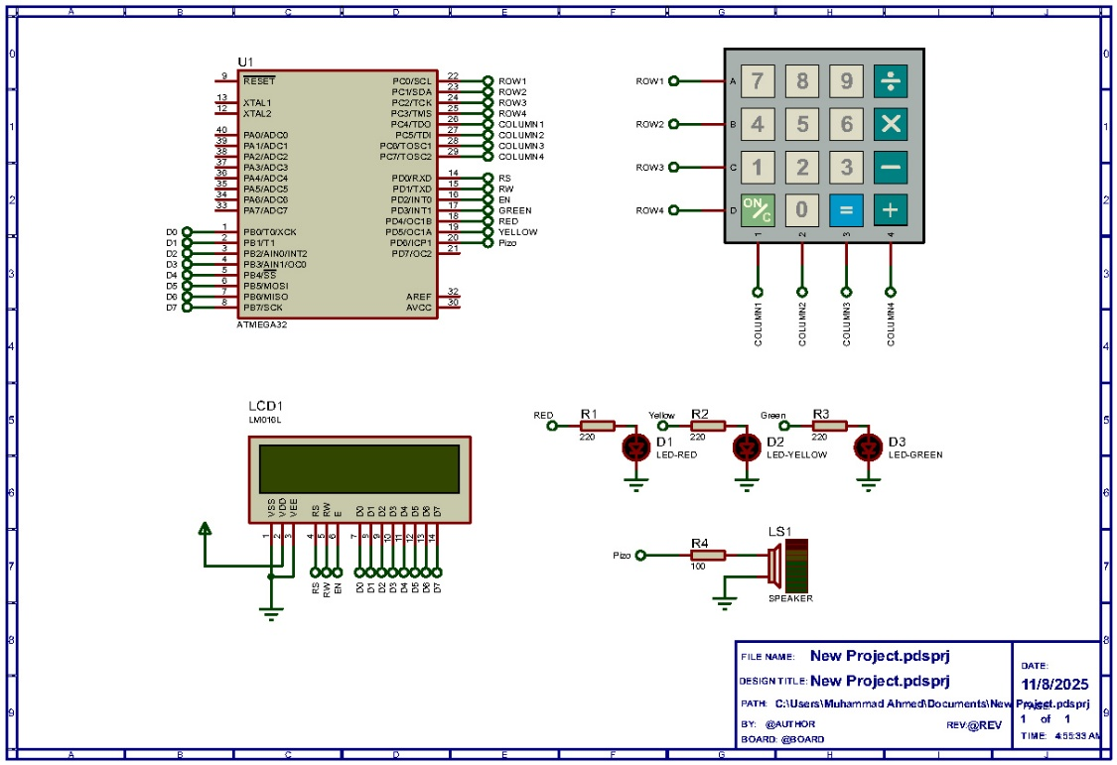
Figure K. 1 Software implementation

K.2 Hardware implementation
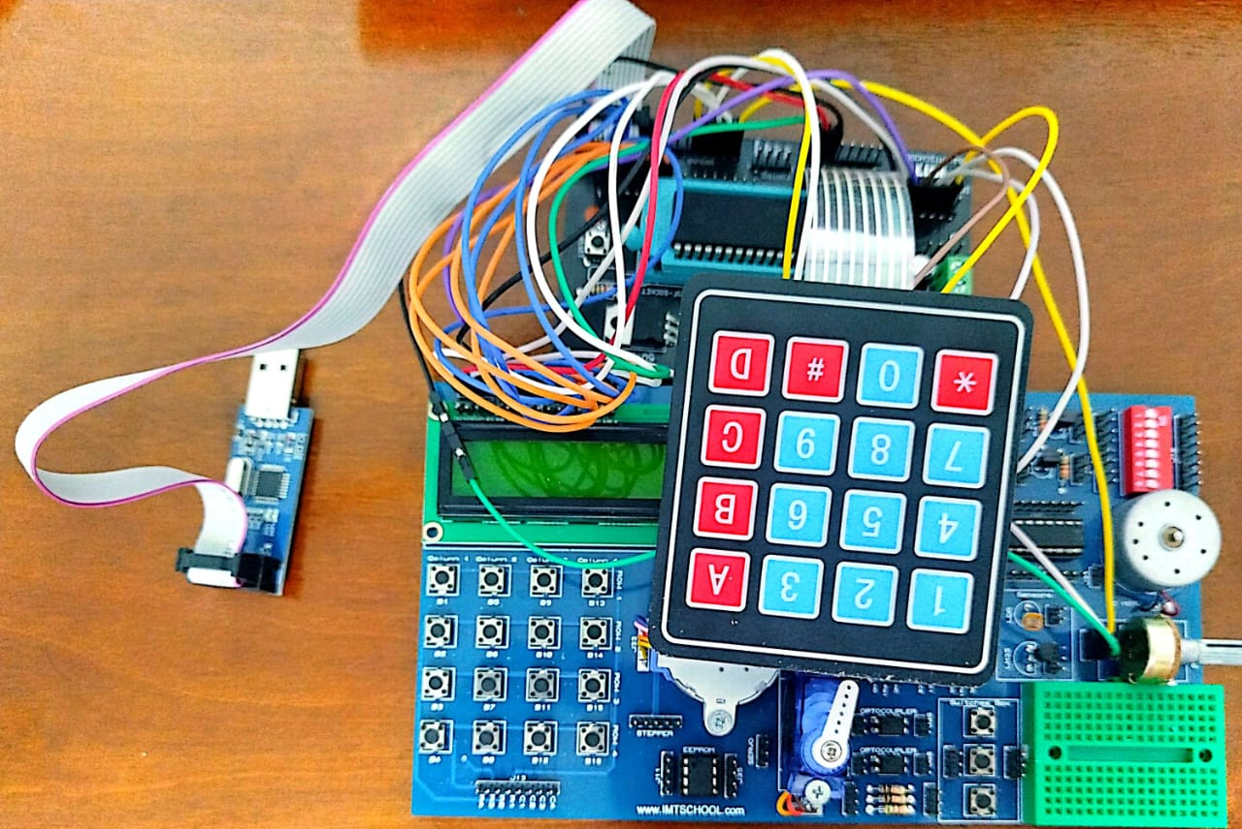
Figure K. 2 Hardware implementation

References

[1] | J. W. Valvano, Embedded Systems: Real-Time Interfacing to the ARM Cortex-M Microcontrollers, 1st ed, 2011.
[2] | M. T. Inc, "ATmega32A Datasheet," 2019. [Online]. Available: https://ww1.microchip.com/downloads/en/DeviceDoc/ATmega32A-DataSheet-Complete-DS-DS40002061A.pdf. [Accessed 2025].
[3] | Atmel, "Interfacing 4×4 Matrix Keypad with AVR Microcontrollers," 2025. [Online]. Available: https://ww1.microchip.com/downloads/en/AppNotes/doc8362.pdf. [Accessed 08 Novamber 2025].
[4] | Hitachi Ltd, "HD44780 LCD Controller Datasheet," 1999. [Online]. Available: https://cdn.sparkfun.com/assets/9/5/f/7/b/HD44780.pdf. [Accessed 08 Novamber 2025].

